PPP(Point to Point Protocol)数据链路层协议。两种认证方式：一种是PAP，一种是CHAP。相对来说PAP的认证方式安全性没有CHAP高。PAP在传输 password是明文的，而CHAP在传输过程中不传输密码，PAP认证是通过两次握手实现的，而CHAP则是通过3次握手实现的。
一、实验配置拓扑图
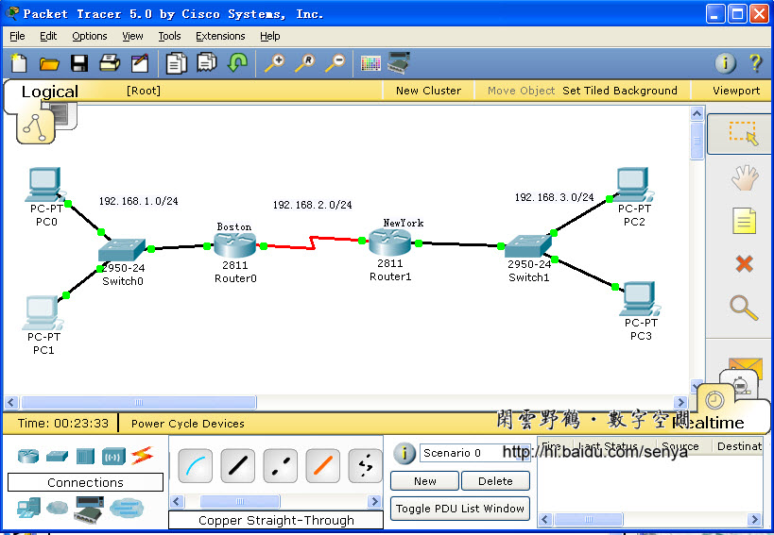
图一
二、PPP的基本配置命令
Router(config-if)#encapsulation PPP
Router(config-if)#PPP multilink
Router(config-if)#PPP authentication chap
三、配置PPP
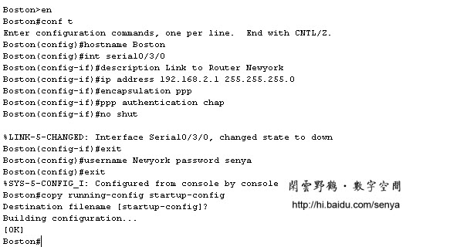
图二 路由器Boson上配置PPP的命令
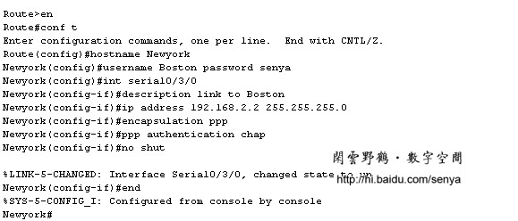
图三 Newyork上配置PPP的命令
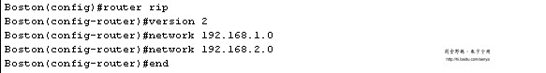
图四 启用RIP路由协议，两个路由器要配置RIP
Boson路由器的配置：
Boston#sh running-config
Building configuration...
Current configuration : 652 bytes
!
version 12.4
no service password-encryption
!
hostname Boston
!
!
!
!
!
username Newyork password 0 senya
!
ip ssh version 1
no ip domain-lookup
!
!
interface FastEthernet0/0
no ip address
duplex auto
speed auto
shutdown
!
interface FastEthernet0/1
ip address 192.168.1.1 255.255.255.0
duplex auto
speed auto
!
interface Serial0/3/0
description Link to Router Newyork
ip address 192.168.2.1 255.255.255.0
encapsulation ppp
ppp authentication chap
clock rate 56000
!
interface Vlan1
no ip address
shutdown
!
router rip
version 2
network 192.168.1.0
network 192.168.2.0
!
ip classless
!
!
!
!
!
line con 0
line vty 0 4
login
!
!
end
Newyork路由器的配置：
Newyork#sh running-config
Building configuration...
Current configuration : 606 bytes
!
version 12.4
no service password-encryption
!
hostname Newyork
!
!
!
!
!
username Boston password 0 senya
!
ip ssh version 1
!
!
interface FastEthernet0/0
no ip address
duplex auto
speed auto
shutdown
!
interface FastEthernet0/1
ip address 192.168.3.1 255.255.255.0
duplex auto
speed auto
!
interface Serial0/3/0
description link to Boston
ip address 192.168.2.2 255.255.255.0
encapsulation ppp
ppp authentication chap
!
interface Vlan1
no ip address
shutdown
!
router rip
version 2
network 192.168.2.0
network 192.168.3.0
!
ip classless
!
!
!
!
!
line con 0
line vty 0 4
login
!
!
end
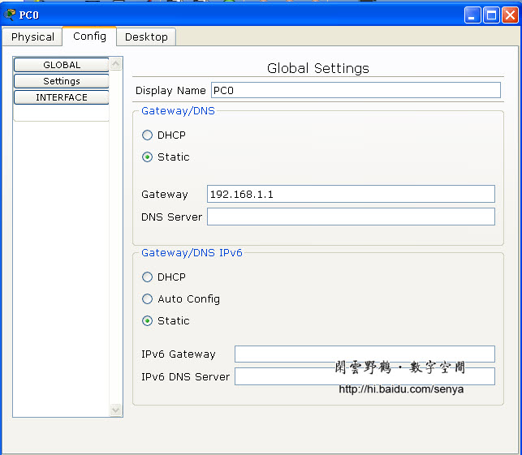
图五 配置计算机的IP地址及网关
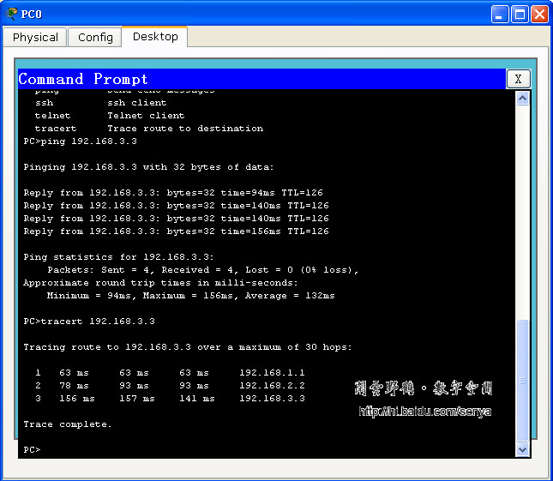
图六 在计算机PC0上使用ping命令检查网络的连通性

